Virginia
Community Service Boards
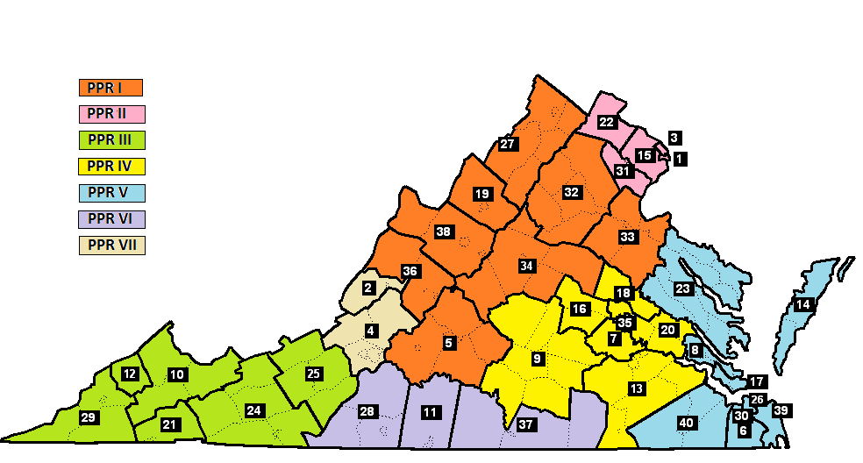

1 | Alexandria | 11 | Danville-Pittsylvania | 21 | Highlands | 31 | Prince William
2 | Alleghany Highlands | 12 | Dickenson | 22 | Loudoun | 32 | Rappahannock-Rapidan
3 | Arlington | 13 | District 19 | 23 | Mid Peninsula-Northern Neck | 33 | Rappahannock Area
4 | Blue Ridge | 14 | Eastern Shore | 24 | Mount Rogers | 34 | Region Ten
5 | Central Virginia | 15 | Fairfax-Falls Church | 25 | New River Valley | 35 | Richmond
6 | Chesapeake | 16 | Goochland-Powhatan | 26 | Norfolk | 36 | Rockbridge Area
7 | Chesterfield | 17 | Hampton-Newport News | 27 | Northwestern | 37 | Southside
8 | Colonial | 18 | Hanover | 28 | Piedmont | 38 | Valley
9 | Crossroads | 19 | Harrisonburg-Rockingham | 29 | Planning District 1 | 39 | Virginia Beach
10 | Cumberland Mountain | 20 | Henrico Area | 30 | Portsmouth | 40 | Western Tidewater

